PRAKTIKUM
SISTEM BASIS DATA

Nama | Wesley Frederick Oh | No. Modul | 6
NPM | 2306202763 | Tipe | Case Study

- Regex
- Regex email: ^[a-zA-Z0-9]+@[a-zA-Z0-9.-]+\.[a-zA-Z]{2,}$
- Regex password: ^(?=.*[0-9])(?=.*[#?!@$%^&*-]).{8,}$
Bagian kode implementasi:
- register
exports.register = async function register(req, res){
//sesuai TP
const emailRegex = /^[a-zA-Z0-9]+@[a-zA-Z0-9.-]+\.[a-zA-Z]{2,}$/;
const passwordRegex = /^(?=.*[0-9])(?=.*[#?!@$%^&*-]).{8,}$/

//bcrpy sesuai daste?
const saltRounds = 10;

if (!req.query.email || !req.query.password || !req.query.name) {
return res.status(400).json({ message: 'Tidak boleh kosong!' });
}

if(req.query.email.match(emailRegex) == null || req.query.password.match(passwordRegex) == null){
return res.status(400).json({ success: false, message: 'Regex tidak terpenuhi' });
}

const hashpassword = await bcrypt.hash(req.query.password, saltRounds);

try {
const result = await pg.query(
'INSERT INTO users(name, email, password) VALUES($1, $2, $3) RETURNING *',
[req.query.name, req.query.email, hashpassword]
);
res.status(201).json({success: true, payload: result.rows[0]});
} catch (error) {
console.error('Error inserting user:', error);
res.status(500).json({ message: 'Fail to register' });
}
}

- update
exports.updateUser = async function updateUser(req, res) {
try {
const { email, password, name, id } = req.body;
const emailRegex = /^[a-zA-Z0-9]+@[a-zA-Z0-9.-]+\.[a-zA-Z]{2,}$/;
const passwordRegex = /^(?=.*[0-9])(?=.*[#?!@$%^&*-]).{8,}$/

if (!email || !password || !name) {
return res.status(400).json({ message: 'Tidak boleh kosong!' });
}

if(email.match(emailRegex) == null || password.match(passwordRegex) == null){
return res.status(400).json({ success: false, message: 'Regex tidak terpenuhi' });
}

const saltRounds = 10;
const hashedpassword = await bcrypt.hash(password, saltRounds);

const response = await pg.query("UPDATE users SET email = $1, password = $2, name = $3 WHERE id = $4", [email, hashedpassword, name, id]);

//res.json(name, address);

if(response.rowCount === 0){
return res.status(404).json({message: "User not found"});
}

const cariuser = await pg.query("SELECT * FROM users WHERE id = $1", [id]);

res.status(200).json({success:true, message: "User data updated successfully", payload: cariuser.rows[0]});
} catch (error) {
res.status(500).json({message: "fail to update user"});
}
}

Kalau tidak memenuhi regex (misal karena password < 8 karakter atau email salah syntax di belakang @):
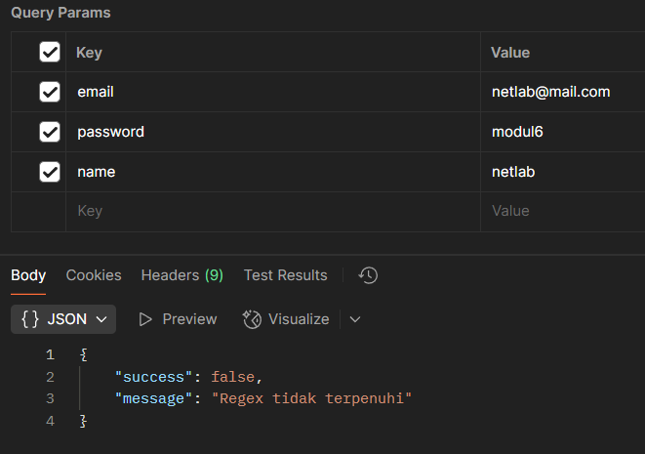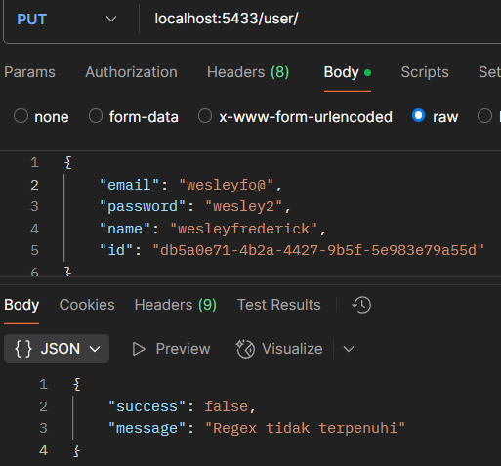
Contoh di atas tidak memenuhi regex karena password < 8 karakter dan tidak ada special karakter.

- Hash
Untuk screenshot/cuplikan kode sama seperti nomor 1 karena berada di function yang sama.

Hasil screenshot database (lihat bagian password di entry 3):
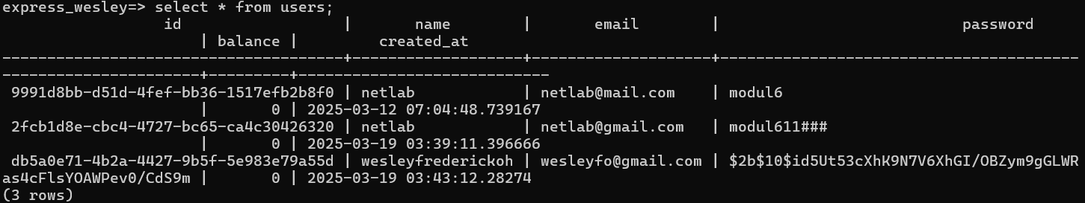
note: entry terakhir adalah yang final, 2 entry di atasnya itu adalah testing saja.
- Compare Password
exports.login = async function login(req, res){
if (!req.query.email || !req.query.password) {
return res.status(400).json({ message: 'Tidak boleh kosong!' });
}

try {
const cariuser = await pg.query("SELECT * FROM users WHERE email = $1", [req.query.email]);

if(cariuser.rowCount == 0){
return res.status(400).json({ message: 'Akun tidak ditemukan.' });
}

const user = cariuser.rows[0];

const isPasswordValid = await bcrypt.compare(req.query.password, user.password);

if(!isPasswordValid){
return res.status(400).json({ success: false, message: 'Password salah' });
}

return res.status(201).json({success: true, message: 'Login succes', payload: user});
} catch (error) {
return res.status(500).json({ success: false, message: 'Gagal login', payload: null});
}
}

- CORS
const express = require("express");
const bodyParser = require("body-parser");
const dotenv = require("dotenv");

const rute = require("./src/routes");
const user_route = require("./src/userroute");
const item_route = require("../CS/src/itemroute");

const cors = require("cors");
dotenv.config();

const port = process.env.PORT || 5433; // Isi nomor port di sini;
const app = express();

var corsOption = {
//origin: 'http://localhost:5433/',
origin: 'http://os.netlab.com/',
methods: ['GET', 'POST', 'PUT', 'DELETE'],
preflightContinue: false,
optionsSuccessStatus: 204
}

app.use(cors(corsOption));
app.use(bodyParser.json());
app.use(express.urlencoded({ extended: false }));

app.use("/store", cors(corsOption), rute);
app.use("/user", cors(corsOption), user_route);
app.use("/item", cors(corsOption), item_route);

app.listen(port, () => {
console.log(`Running on port ${port}!`);
});

- Memasukkan query
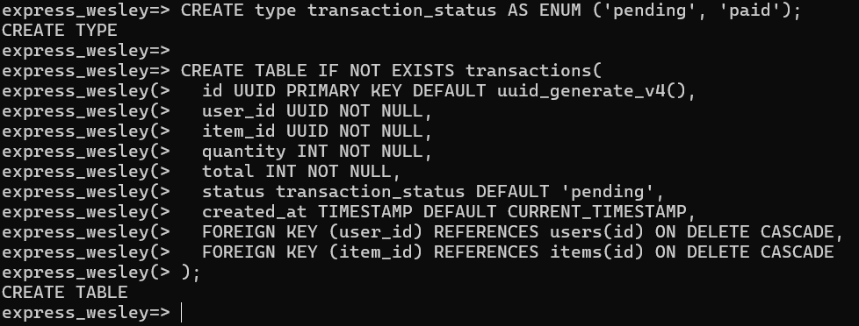
- Screenshot Response
Method | Endpoint | Success | Failed
POST | /user/register | 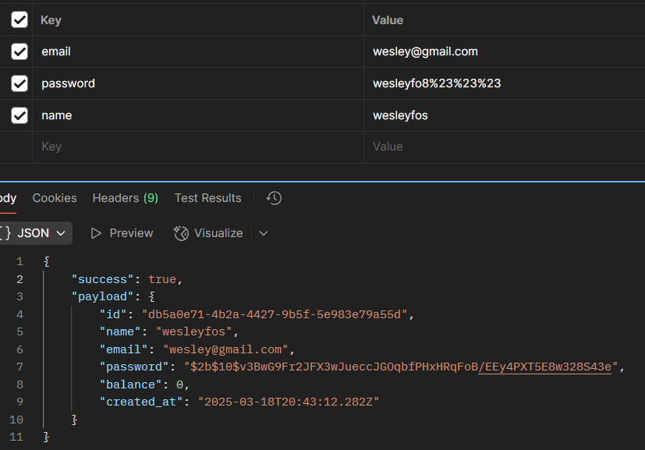 | 
PUT | /user | 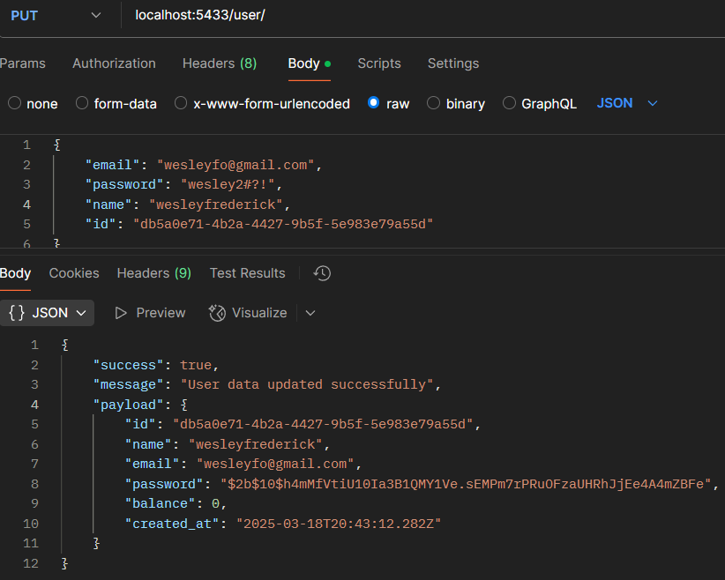 | 
POST | /user/login | 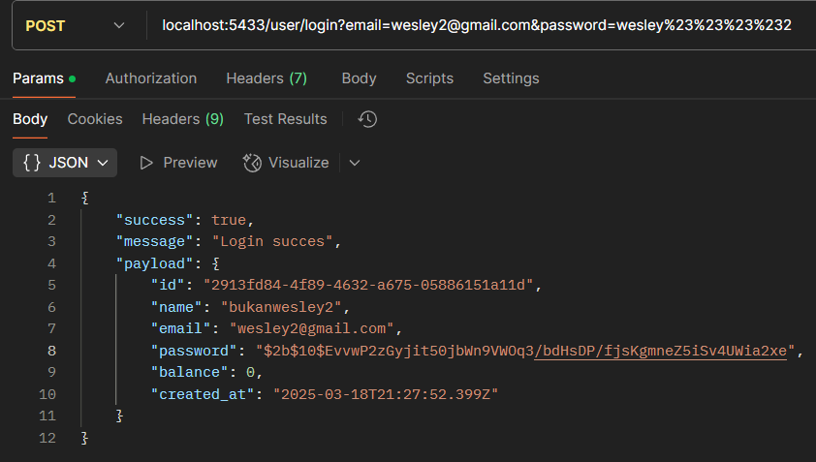 | 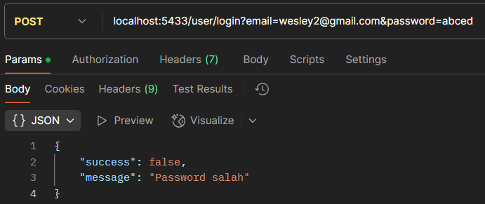
POST | /user/topUp | 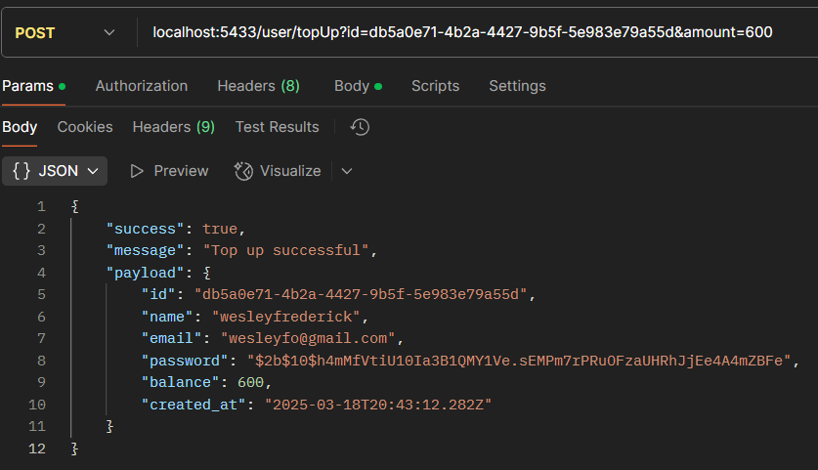 | 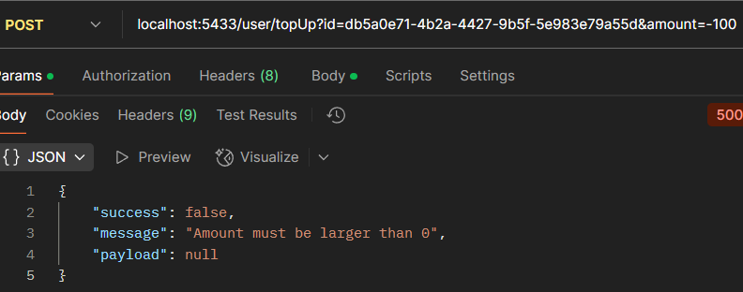
POST | /transaction/create | 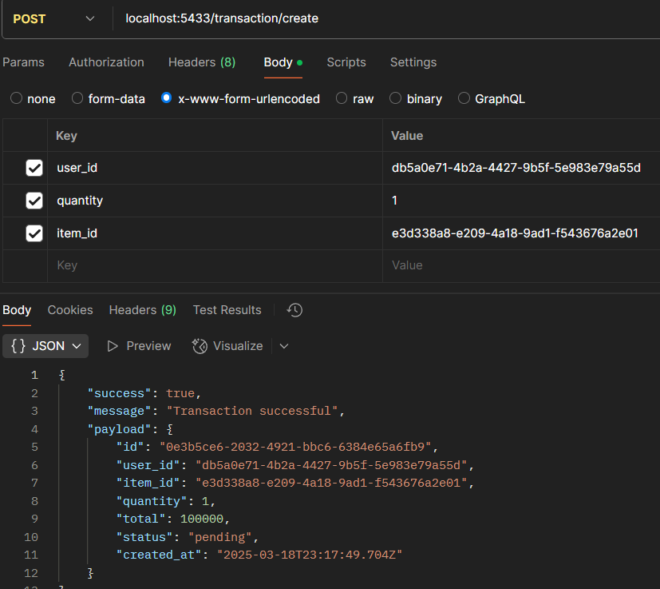 | 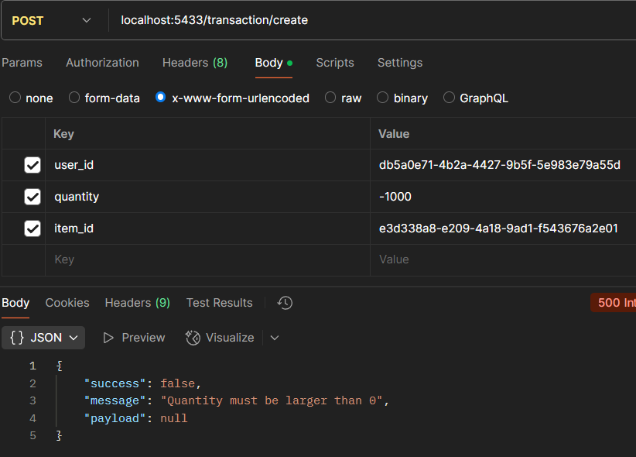
POST | /transaction/pay | 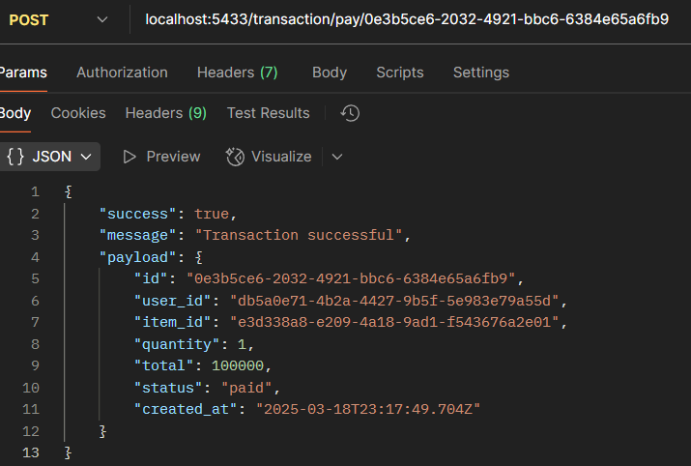 | 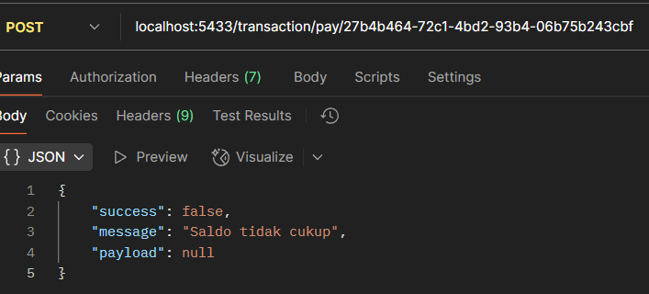
DELETE | /transaction/:id | 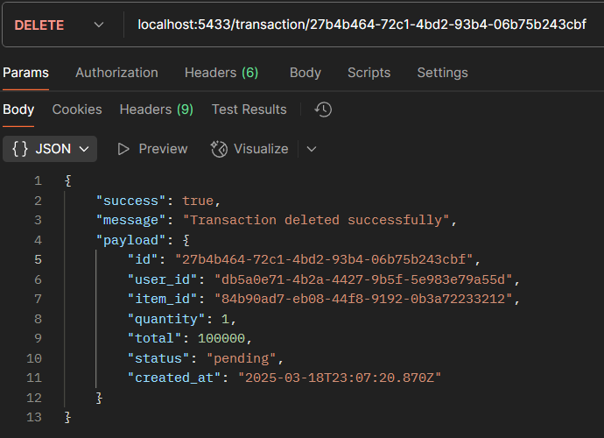 | 